1. **Create a list of first 5 even numbers using list comprehension.**

**Code:**

**#Program to print first five even numbers**

**list1=[i for i in range(1,11) if i%2==0]**

**print("list is",list1)**

**Output:**

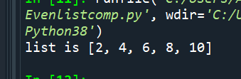

**2. Write a Python program to Multiply every element of a list by five and assign it to a new list using list comprehension.**

**Code:**

**#Program to multiply elements of a list by 5 and store in another list**

**l1=int(input('Enter the length of the list'))**

**list1=[]**

**for i in range(0,l1):**

**n=int(input("Enter element"))**

**list1.append(n)**

**list2=[x*5 for x in list1]**

**print(list2)**

**Output:**

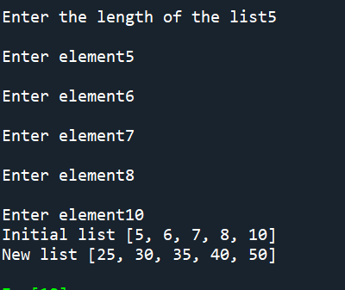

**3. Write a program using list comprehension to extract and print all the numbers from a given**

**string.**

**Code:**

**#Program to extract numbers from a given string**

**s=input("Enter string")**

**list1=[x for x in s if x.isdigit()==True]**

**print(list1)**

**Output:**

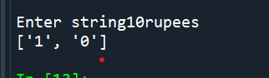

**4. Write a Python program to Matrix addition and Multiplication using list comprehension.**

**Code:**

**#Matrix addition and multiplication**

**matrix1=[[j for j in range (3)] for i in range (3)]**

**print("Matrix 1")**

**for i in range(len(matrix1)):**

**print(matrix1[i])**

**matrix2=[[x for x in range(3)] for y in range(3)]**

**print("Matrix2")**

**for i in range(len(matrix2)):**

**print(matrix2[i])**

**result1=[[matrix2[j][i]+matrix1[j][i] for i in range(len(matrix1))]for j in range(len(matrix2))]**

**print("On adding")**

**for i in range(len(result1)):**

**print(result1[i])**

**result2=[[sum(a * b for a, b in zip(matrix1_row, matrix2_col))for matrix2_col in zip(*matrix2)]for matrix1_row in matrix1]**

**print("On multiplying")**

**for r in result2:**

**print(r)**

**Output:**

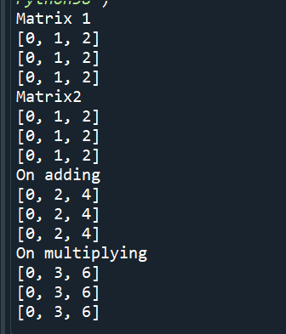

**5. Write a Python program to create a new list of Numbers that are divisible by 7 from all the numbers in the range of 1-1000.**

**Code:**

**#Program to print all numbers divisible by 7 in 1 to 1000**

**list1=[i for i in range(1,1000) if i%7==0]**

**print(list1)**

**Output:**

